08/09/2025

**SLICER**

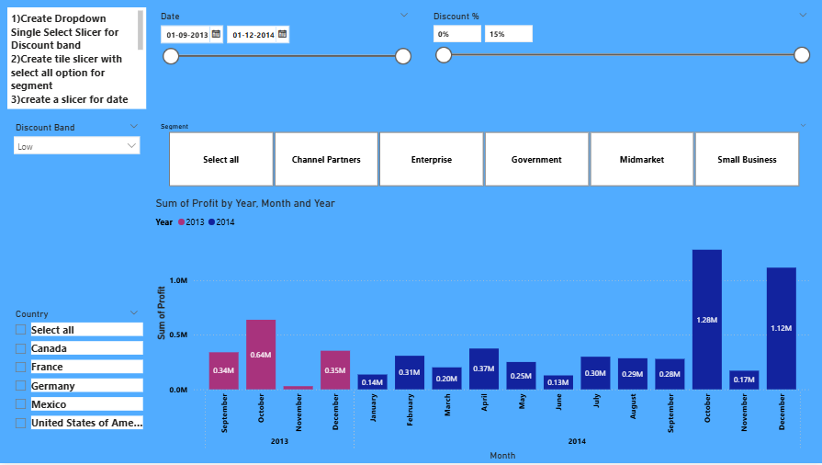

**Format Page** → Canva Background → color → Blue

To create a **Slicer:**

1. go to **Visualizations** and select the Slicer.
2. On the Field place the **Date.**

**Format Visual** → Slicer Setting → Option → Between → Values → font style

**Slicer Header** on.

**Format Visual** → General → Effect→ Background → color blue

**Slider** on.

To create a **Slicer:**

1. go to **Visualizations** and select the Slicer.
2. On the Field place the **Discount.**

**Format Visual** → Slicer Setting → Option → Between → Values → font style

**Slicer Header** on.

**Format Visual** → General → Effect→ Background → color blue

**Slider** on.

To create a **Slicer:**

1. go to **Visualizations** and select the Slicer.
2. On the Field place the **Discount Bond.**
3. **Format Visual** → Slicer Setting → Option → Dropdown → Selection Single Selection

**Slicer Header** on.

**Format Visual** → General → Effect→ Background → color blue

To create a **Slicer:**

1. go to **Visualizations** and select the Slicer.
2. On the Field place the **Discount Bond.**
3. **Format Visual** → Slicer Setting → Option → Style Vertical list or Tile or Dropdown → Selection Single Selection or Multi-select or Show select all

**Slicer Header** on.

**Format Visual** → General → Effect→ Background → color blue